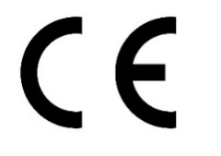
EC Declaration of Conformity

Manufacturer and address:
Kunshan Yiyuan Sporting Goods., Ltd
No. 1800-11 West Road of China Garden,
YuShan Town, KunShan City, JiangSu Province, China

Trade Agent: Shanghai Cathay I.T. CO. LTD
Address: #9 Villa, 2000 Gudai Road Minhang District,Shanghai 201101 P. R. China

Product description
Helmets for pedal cyclist, skateboarders and roller skaters
Product Reference(s): Y-03S
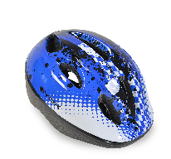
Size Range & Mass: 48-54 cm; 210 g
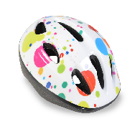

The submitted product is manufactured in accordance with the requirements of Regulation (EU) 2016/425 on Personal Protective Equipment of the European Parliament and of the Council

We herewith declare that the above mentioned product(s) comply with the relevant European Standard
EN 1078:2012+A1: 2012

Conformity is certified with:
*Test report No: SZHH01109304,
Issued by: Intertek Testing Services Shenzhen Ltd., Hardlines
*EC Type Examination Certificate No: LECFI00366375
Approved body 0362

January 10th,2017

ЕО Декларация за съответствие

Производител и адрес:
Kunshan Yiyuan Sporting Goods., Ltd
No. 1800-11 West Road of China Garden,
YuShan Town, KunShan City, JiangSu Province, China

Търговски агент: Shanghai Cathay I.T. CO. LTD
Address: #9 Villa, 2000 Gudai Road Minhang District,Shanghai 201101 P. R. China

Описание на продукта
Каска за потребители на велосипед, скейтборд и ролери
Продуктов номер: Y-03S
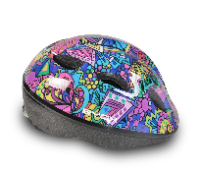
Обиколка на главата и тегло: 48-54 cm; 210 g

Предоставеният продукт е произведен в съответствие на изискванията на Регламент (ЕС) 2016/425 на Европейския парламент и на Съвета от 9 март 2016 година относно личните предпазни средстваза

Ние с това декларираме, че гореспоменатият продукт(и) отговаря на изискванията на съответния Европейски Стандарт EN 1078:2012+A1: 2012

Съответствието е удостоверено с:
*Test report No: SZHH01109304
Issued by: Intertek Testing Services Shenzhen Ltd.,Hardlines
*EC Type Examination Certificate No: LECFI00366375
Approved body 0362

January 10th,2017

